Still ID3:
The training procedure looks to minimize the SD of the target on each decision node
Procedure: Compute the SD of the target: 𝑺𝑫 (𝑻). - Compute the SD for each target and feature: . - Compute the SD reduction (SDR) considering each feature as decision node and select the feature with higher SDR:
Another example:
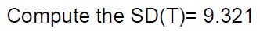
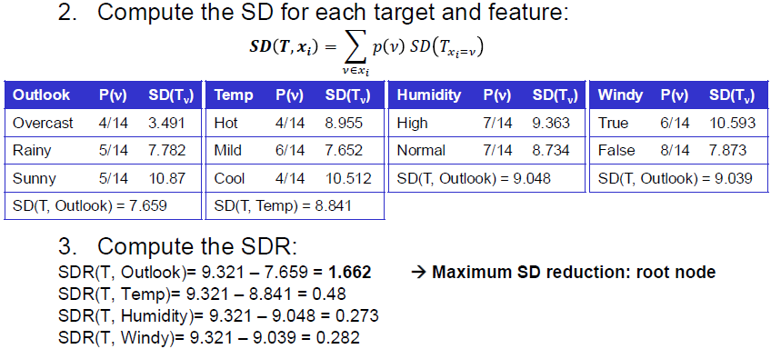
C4.5:
Gain Ratio: incorporates a term sensitive to how broadly and uniformly the attribute split the data
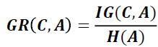
Example:
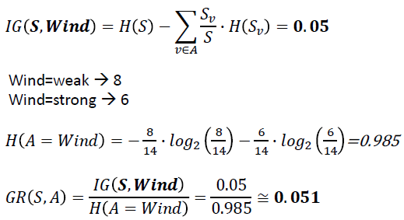
Missing values: assign the most common value within the instances of the same class.
Support Vector Machines: Find the hyperplane that best divides a dataset into two classes.
ID3 – example:
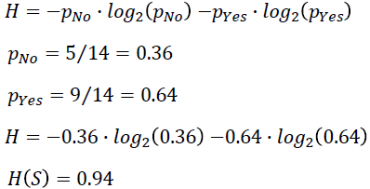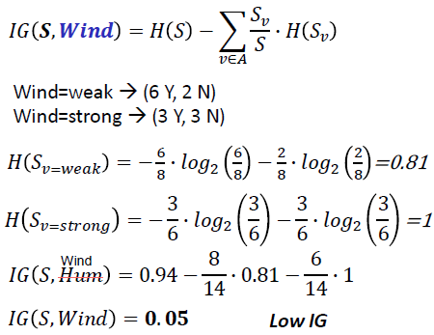
Entropy:
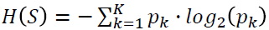
Information Gain: measures how well a given attribute separates the training data according to their target classification
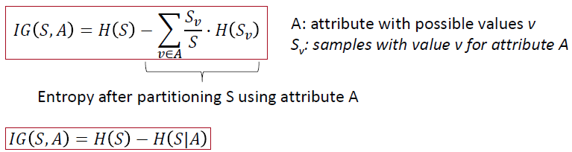
ID3:
- Select the most important attribute to place at the root node, i.e. attribute with the highest Information Gain. - Make a branch for each possible value. - Repeat the process (attribute selection) for each branch using only the instances in the branch. Any attribute can appear at most once along any branch through the tree.

Naïve Bayes example:
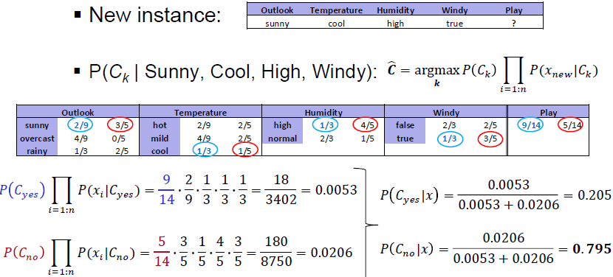
Naive Bayes:
Bayes Theorem: For classification problems:
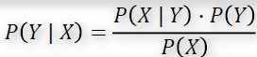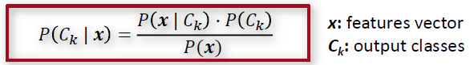
Because features are assumed independent:
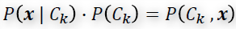 M = P(x)
Probability of class Ck:
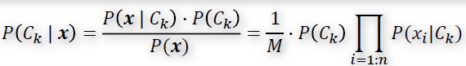
Assigned class to a new sample will be:
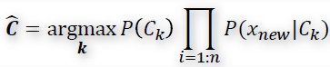
Artificial Neural Network:
Input, hidden and output variables are represented by nodes. Nodes are organized in layers. The weights are the links between nodes. The network can be fully connected or sparse, i.e. not all connections are present
Feed Forward NN: Data flows forward between layers, with no loops or cycles. (Gradient Descent: the 𝒘 update comprise a small step in the direction of negative gradients: at each step, 𝒘 is moved in the direction of the greatest rate of decrease of E(𝒘), Backpropagation: the derivatives of the errors are propagated back through the network, to adjust 𝒘)
Convolutional NN: Nearby pixels are more strongly correlated than more distant pixels.
OneRule – Example:
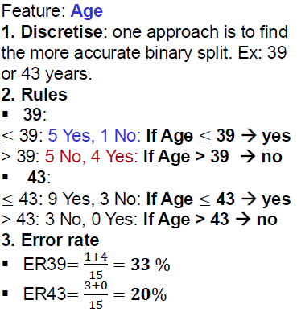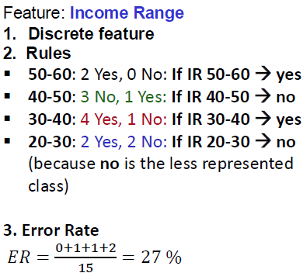
Choose the rule with the smallest ER
ZeroRule (ZeroR):
Algorithm that classifies all samples in the test set into one class: the majority class in the train set.
Random Classifier:
Randomly assigns a class to each instance
OneRule (OneR):
Learn rules from a single feature (not a single rule).

